Technichal Report: Comparative analysis of algorithms on Linear Model

Samama Imtiaz Butt
Department of Computer Science, National University of Computer and Emerging Sciences Lahore, Pakistan
l181882@lhr.nu.edu.pk

Abstract— Nowadays Artificial Intelligence is picking up steam focusing on learning data on computers through big data analysis. In this report, we train and test a linear model for pattern analysis in solving handwritten digit recognition and urban sound classification problems. By using the basic algorithms/definition, Linear Model has been implemented from scratch. The learning process of this report is comparing and analyzing the results of accuracy through Linear Model supervised learning based on correct Test Labels. In conclusion, we present this conclusion as this model can really be applied to solve the real world problems.

Keywords—component, formatting, style, styling, insert (key words)

Introduction to linear model
In Machine Learning, any ‘object’ created after getting trained from a learning algorithm is called a model. From this definition of model, we can say that Model is a combination of two things ‘Data’ and ‘Algorithm’.
Algorithm finds patterns in ‘Training Data’ such that input parameters corresponds to the target. There are two types of ML Models we have studied so far i.e. Supervised Learning Model and Unsupervised Learning Model.
Our objective is to find the class of an object by using its characteristics. Linear Model a type of Supervised Learning Model and most commonly used model in ML. It can be described as a linear combination of features. The learning algorithm generates a weight for each feature to form a model that predict or estimates the target output. We can also say that linear model separates the data into two classes by using a straight line. This model works well on the datasets which linearly separable. As you can see in the figure below:
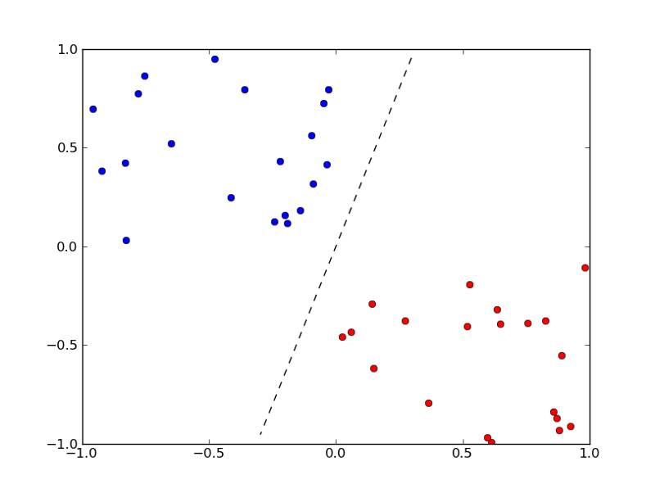

Normal equation
First we have implemented the Normal Equation. In this method, we created a matrix of size n x n. Our goal is to find a vector W of weights by multiplying which we can predict the output Y. Simple form of normal equation is:
M W = Y (1)
To compute the weight vector W, we need to perform the following operations:
- As we have to find the vector W, we multiply transpose of matrix M on both sides of equation (1).
MT M W = MT Y
- Moving the left hand side to the right except the vector W. We will get:
W = (MT M) −1 MT Y
Finally, we use the above equation to compute the vector W in our algorithm and to get the output Y by putting the vector W in equation (1).

gradient descent
Gradient Descent is the most popular optimizing algorithm in machine learning and can be easily combined with any other algorithm. It is used to train a model by iteratively updating a function to reduce the cost function to its local minimum.
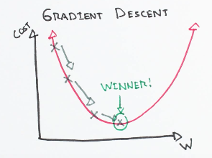
Cost function is used to measure the performance of a machine learning model. It calculates the loss or error between the actual and expected value and represents it in a form of single real number. It returns two types of values either it returns the smallest number i.e. error, loss, cost etc. or returns the maximum number i.e. reward. There are many types of cost function but I have used mean squared error in my algorithm which can be written as following:
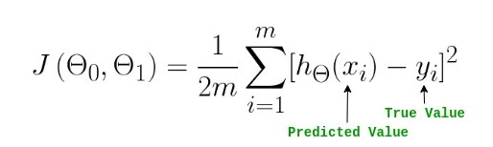
By taking the derivative of this cost function, we can compute the gradient of our linear model.
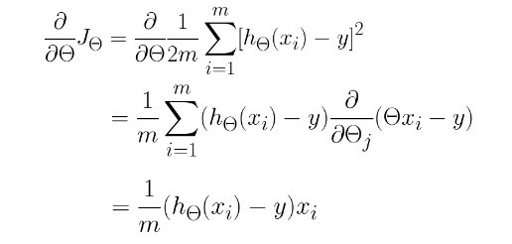
“A gradient measures how much the output of a function changes if you change the inputs a little bit.” — Lex Fridman (MIT)
Amount of step that gradient should take into the direction of local minimum is called learning rate. If this step is too large then we will not be able to find the minimum. If we take it to small then it will going to increase the number of iterations to find the minimum. So, we can say that it plays an important role in computing gradient descent.
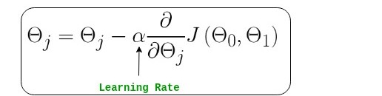
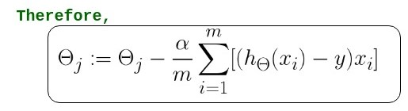
There are three types of gradient descent written as following:

Batch Gradient Descent
Uses whole training data per epoch.

Stochastic Gradient Descent
Uses one training example per epoch.

Mini-Batch Gradient Descent
Uses a set of training examples per epoch.

Perceptron
In 1957, Frank Rosenblatt started investigating the Artificial Neural Network at the Cornell Aeronautical Laboratory which he later called Perceptron. We can relate Perceptron to the neuron information processing where a neuron accepts signals from dendrites and passes electoral signals down to the cell body.
Similarly, Perceptron takes input from training data that we weight and combined it in a linear equation. Combined Linear Equation generates an output or prediction using transfer function. It can be described as a classification algorithm for problems with two classes i.e. 0 and 1 where a linear equation can be used to separate two classes. A perceptron can have multiple inputs but outputs only a binary label.
In perceptron learning, we create a weight vector by initializing the weights randomly. Then we update these weights by iteratively applying perceptron rule to each training data input. The process is being repeated until the correct classification of each training example.
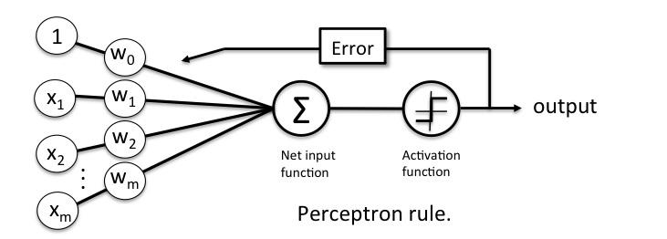
Perceptron is further divided into two types;

Single Layer Perceptron
It only learns linearly separable patterns.

Multilayer or Feedforward Perceptron
It has greater processing capacity and can learn non-linear patterns.

kernel perceptron
Kernel Methods maps a non-linear function into a linear function in a much higher dimensional space. Thus they enable linear discriminant methods to be applied to a large class of problems where the data are dispersed in a non-linear manner. Linear methods are very well suited for use with very high dimensional feature space provided that the patters can be separated by a plane. Kernel Methods provide an elegant solution for clustering and classifying patterns in complex non-linear data by mapping the data into a higher dimensional space where the data can be separated by a linear method.
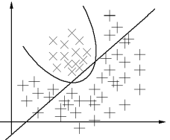
Kernels make it possible to
- Solve the computational problems of high dimensional spaces
- Be extended to infinite dimensional spaces
- Be extended to non-numerical and symbolic data!

SVM HOG
Histogram of oriented gradients (HOG) is a feature extraction technique for the detection of objects. Its essence is that the shape of an object in an image can be described by means of the intensity distribution of the gradients. The great advantage of a detector obtained using HOG descriptors is that it is invariant to rotation, translation, scaling and illumination changes. Therefore, it has been applied successfully in both visible spectrum images and infrared images. After using HOG descriptors, support vector machines (SVM) are usually used in the classification stage. SVM are a set of supervised learning algorithms which were introduced for linearly separable and linearly non-separable data. SVM have been used in classification and regression problems in many fields such as text recognition, bioinformatics and object recognition, among others. They have also been used successfully in the detection of persons.

Datasets
A dataset is a collection of data. Dataset should be arranged in an order which can be processed easily. Following data sets are being used for the implementation of linear model:
- MNIST Digit Recognizer
- Urban Sound Classifier

MNIST Digit Recognizer

MNIST (Modified National Institute of Standards and Technology Database) is the commonly used dataset for learning, classification and computer vision systems also known as the de facto “hello world” dataset. It has extracted from the NIST Special Database 19. The dataset is separated into two branches training and test extending from 0 to 9. The MNIST database comprises of images of handwritten digits having 60,000 examples of training data and has a test set of 10,000 examples.

The training set has collected from approximately 250 writers, and 60,000 patterns were extracted from this training set. This dataset is collected in a way that examples in both sets does not intersects each other.

Images are normalized and centered with a fixed size of 28 * 28 or 784 pixels in total. Following are the sample images taken from the dataset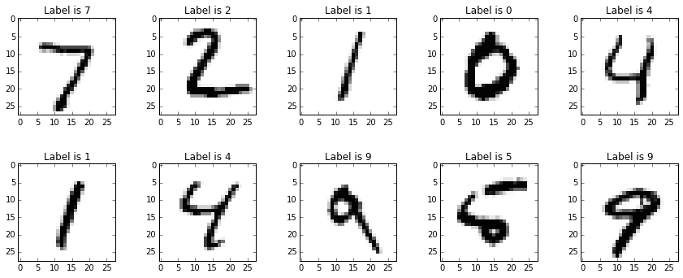

Urban Sound Classifier
The Urban Sound dataset comprises of 1302 labeled sound recordings consisting of 10 classes i.e. Air Conditioner, Car Horn, Children Playing, Dog Bark, Drilling, Engine Idling, Gun Shot, Jackhammer, Siren, and Street Music. Each class may contain audio of multiple classes but it is labelled with single class separated by folders.
Like MNIST dataset, it consists of two sets of data i.e. training and test set. If one slice from a certain recording was in training data, and a different slice from the same recording was in test data, this might increase the accuracy of a final model falsely. The biggest challenge in this dataset is that the sizes of the audio files are not fixed and can vary from 1-2 s to over 30 s.

Accuracy
While working with the machine learning models, it is very important for them to generalize the training data instead of overfitting it. We must evaluate our model in order to verify its performance which is a main factor of a classification model. It quickly tells us that whether the model is being trained correctly and how it may perform generally. It can be determined by the calculating its accuracy. To calculate the accuracy of a model, we need divide total number of correct predictions by the total predictions. As shown in the figure below:

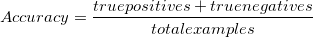
Accuracy works well when you have symmetric datasets which means that there is no classification imbalance in the dataset.

Algorithm | Dataset | Digit | Accuracy
Normal Equation | MNIST | 0 | 91%
Gradient Descent with NE | MNIST | 0 | 92%
Perceptron | MNIST | 0 | 8.5%
Normal Equation | MNIST | 1 | 97.5%
Gradient Descent with NE | MNIST | 1 | 97.5%
Perceptron | MNIST | 1 | 14%
Normal Equation | MNIST | 2 | 94.5%
Gradient Descent with NE | MNIST | 2 | 94.5%
Perceptron | MNIST | 2 | 8%
Normal Equation | MNIST | 3 | 92.5%
Gradient Descent with NE | MNIST | 3 | 93%
Perceptron | MNIST | 3 | 8%
Normal Equation | MNIST | 4 | 87.5%
Gradient Descent with NE | MNIST | 4 | 88%
Perceptron | MNIST | 4 | 14%
Normal Equation | MNIST | 5 | 89%
Gradient Descent with NE | MNIST | 5 | 90%
Perceptron | MNIST | 5 | 10%
Normal Equation | MNIST | 6 | 93%
Gradient Descent with NE | MNIST | 6 | 93%
Perceptron | MNIST | 6 | 10%
Normal Equation | MNIST | 7 | 89.5%
Gradient Descent with NE | MNIST | 7 | 90%
Perceptron | MNIST | 7 | 12%
Normal Equation | MNIST | 8 | 94%
Gradient Descent with NE | MNIST | 8 | 94%
Perceptron | MNIST | 8 | 5%
Normal Equation | MNIST | 9 | 90%
Gradient Descent with NE | MNIST | 9 | 90.5%
Perceptron | MNIST | 9 | 10.5%
Whereas accuracy of SVM HOG on MNIST dataset is 97% and accuracy of Kernel Perceptron is 80%,

Conclusion
It has been observed in these experiments that SVM HOG outperformed all other algorithms. Unfortunately, results on Urban Sound dataset has not mentioned in this report since it was taking too much execution.

References

- Yann LeCun, Corinna Cortes. THE MNIST DATABASE of handwritten digits. http://yann.lecun.com/exdb/mnist/index.html
- Tom M. Mitchell. Machine Learning. McGraw Hill, 1997
- D. Bogdanov, N. Wack, E. G´omez, S. Gulati, P. Herrera, O. Mayor, G. Roma, J. Salamon, J. Zapata, and X. Serra. ESSENTIA: an open-source library for sound and music analysis. In 21st ACM Int. Conf. on Multimedia, pages 855–858, 2013.
- Yutaka matsuo, Artificial intelligence and Deep Learning. ISBN 979-11-86008-23-2

